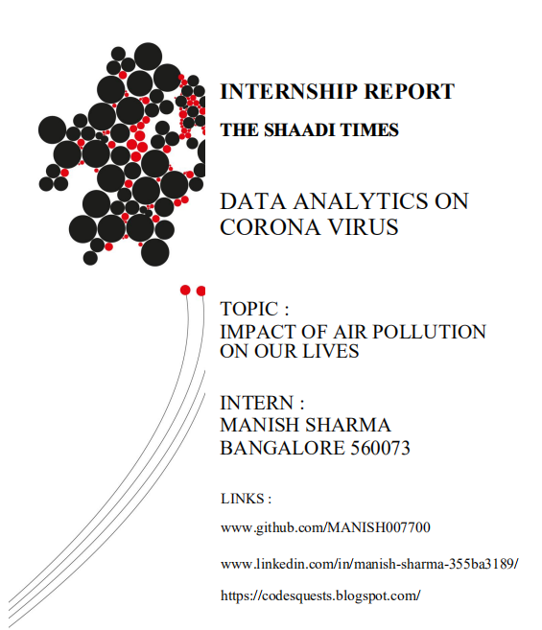

***Internship description***

My role at THE SHAADI TIMES was to provide an insights on the on-going Corona Virus Case and how the Air pollution have struck the human lives as well as the location and state suffered.

***Overview of internship experience***

During my internship experience with THE SHAADI TIMES , I was able to develop my Data Analyst Skills as well as my visualization part and , I particularly found this experience to be useful in improving my skill .

Although I found many tasks to be challenging, I found it to be valuable in developing my skill .

***Ongoing consideration***

While I had many useful experiences at THE SHAADI TIMES, I feel that I still need to develop my confidence level with Data Scraping part , I would have enjoyed more time completing this task !

**In conclusion**

My experience with THE SHAADI TIMES was crucial in my development as a DATA ANALYST. I will take the lessons and skills I learned and apply them to my next position.

INDEX :

1 . About this Report

2 . What and Why PM 2.5 ?

3 . Range of PM 2.5

4 . Rank of India in terms of Pollution

5 . Datasets Used

6 . Visualization on the pollution effect PRE Lockdown (2018-2019)

7 . Visualization on the pollution effect POST lockdown (2020 -recent )

8 . Measures to be taken

9 . My Experience

***1 . About this Report !***

The 2019 -20 World Air Quality Report is based on data from the world’s largest centralized platform for real-time air Through aggregating, validating and visualizing real-time data from governments and sensors operated by inThe 2019 World Air Quality Report is based on a subset of the information provided through the platform. It inIt includes So2,No2,PM2.5 (fine particulate matter) data as acquired from ground-based air quality monitoring stations with high data availability.

***2 . What and Why PM 2.5 ?***

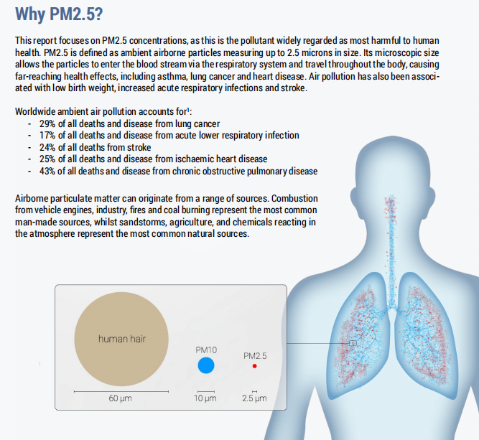

***3 . Range of PM 2.5***

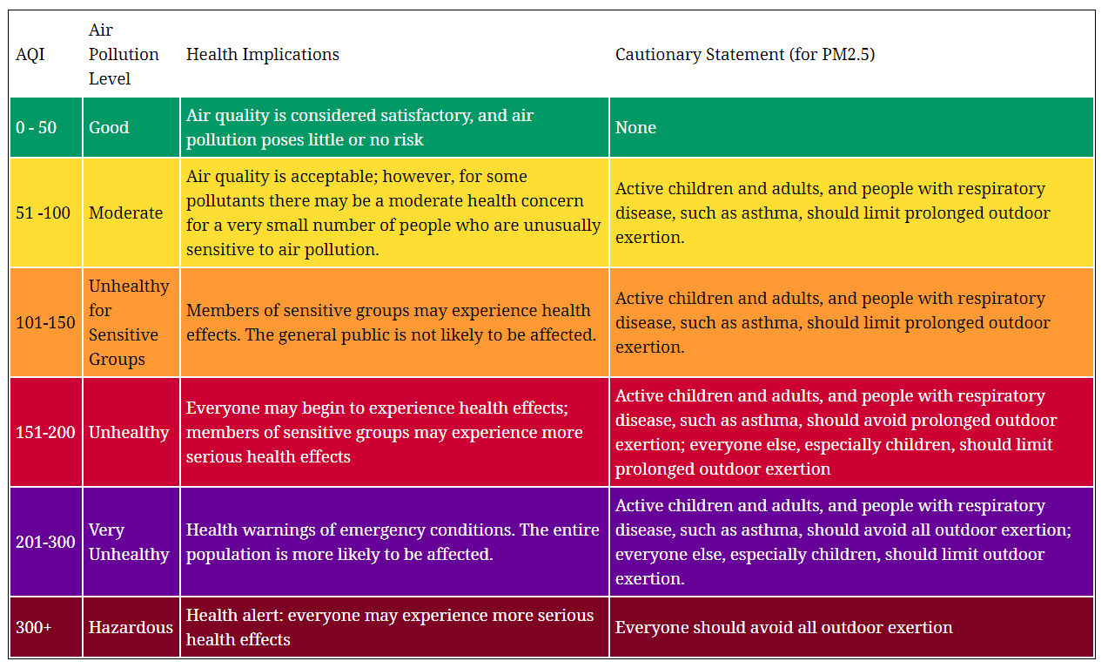

***4 . Rank of India***

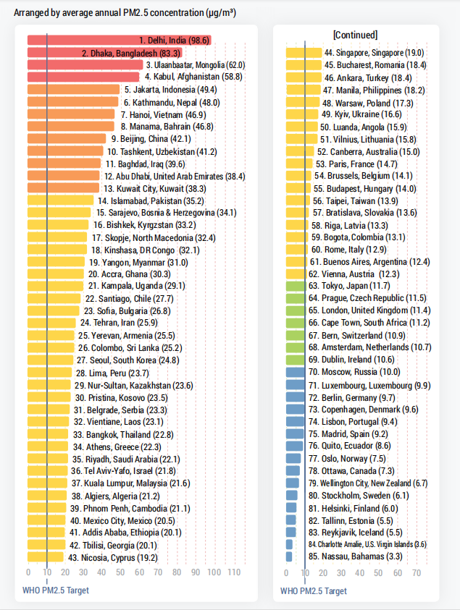

***5. Datasets Used !***

***Air Quality Open Data Platform 2018-19***

***Air Quality Open Data Platform 2019 – recent***

<https://aqicn.org/data-platform/covid19/>

***Features in DataSets :***

***SO₂:***

***Sulphur Dioxide is a gas. It is one of the major pollutants present in the air.***

***It is colourless and has a nasty, sharp smell.***

***It combines effortlessly with other chemicals to form harmful substances like sulphuric acid, sulfurous acid, etc.***

***NO₂:***

***Nitrogen Dioxide is a reddish-brown gas with a pungent, acrid odour.***

***It can cause bronchoconstriction, inflammation, reduced immune response, and may have effects on the heart. Direct exposure to the skin can cause irritations and burns.***

***The following gives a rough idea of nitrogen dioxide’s impact on health :***

***10–20 ppm can cause mild irritation of the nose and throat***

***25–50 ppm can cause oedema leading to bronchitis or pneumonia***

***Levels above 100 ppm can cause death due to asphyxiation from fluid in the lungs.***

***Particulates:***

***These are also known as Atmospheric aerosol particles, atmospheric particulate matter, particulate matter (PM) or suspended particulate matter (SPM).***

***These are microscopic solid or liquid matter suspended in the atmosphere.***

***Particulates are the deadliest form of air pollution due to their ability to penetrate deep into the lungs and bloodstreams unfiltered, causing permanent DNA mutations, heart attacks, respiratory disease, and premature death.***

***PM 2.5 :***

***Worldwide exposure to PM 2.5 contributed to 4.1 million deaths***

***from heart disease and stroke, lung cancer, chronic lung disease,***

***and respiratory infections in 2016. Overall, ambient particulate matter ranks as the sixth leading risk factor for premature death globally.***

***6 . Visualization on the pollution effect PRE Lockdown (2018-2019)***

***“All the codes for the below visualization and codes can be found in my github”***

[*www.github.com/MANISH007700*](http://www.github.com/MANISH007700)

*>>Total Count of Cities and Data*

*>> effect of So2 in Indian Cities*

*>> effect of No2 in Indian Cities*

*>> effect of Pm25 in Indian Cities*

*>>effect on Respiration in Indian Cities*

***Info : Good range for So2 – 10 – 35***

***Good range for No2 – 10 - 25***

*1 .* **Total Data From Cities in India** *:*

*We can observe below that we had a total of 100+ Air Quality Index data scraped from different cities across India !*

*Total Distinct Count -- 19 Cities*

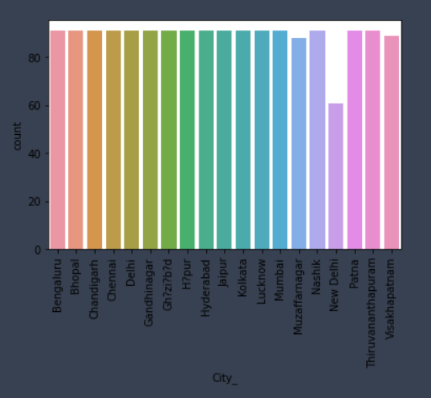

*Every city except New Delhi has equal data which is really good to bring good insights*

*2 .* **Effect of So2 around the Cities** *:*

*As we can see below* ***“Gandhinagar”(Gujarat)*** *is way ahead in avg So2 count* ***(27)******ppbv*** *before the Covid-19 lockdown followed by* ***“Patna”(Bihar) (17)******ppbv*** *and the metro city* ***“Mumbai”(Maharashtra)(16)ppbv***

***Ppbv – Parts per Billion Volume (Unit for measuring air quality)***

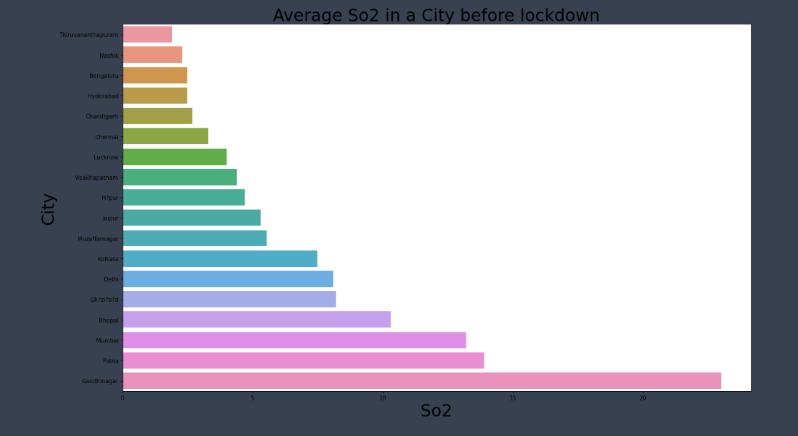

***3 .* Effect of No2 around the Cities :**

*As we can see below* ***“Kolkata”(West Bengal)*** *tops the chart with avg count of* ***31 ppbv*** *followed by again* ***“Gandhinagar”(Gujarat)*** *with* ***30*** *and not shocking ‘****Ghaziabad’(Uttar Pradesh) with 24***

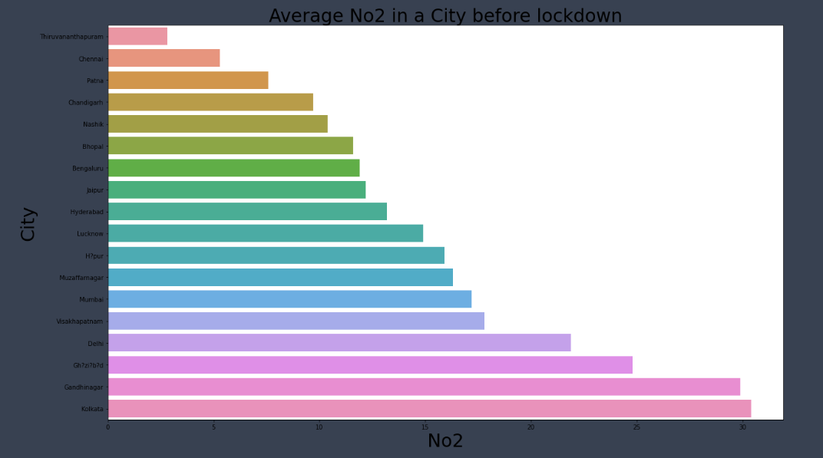

***4 .* Effect of Pm2.5 around the Cities :**

*As we can see below* ***“New Delhi”***  *tops the chart with avg count of* ***180 ppbv*** *followed by again* ***“Patna”(Bihar)*** *with* ***173*** *and not shocking ‘****Ghaziabad’(Uttar Pradesh) with 170***

***These number are terrific and bad as you can see in the above chart for range of pm2.5***

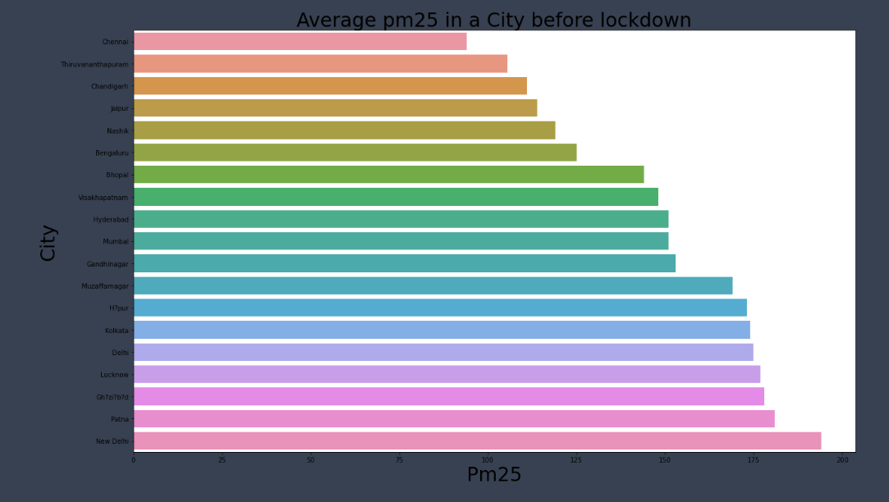

**5 . Respiratory Affected Cities (Based on Pm2.5) :**

*Since , this respiratory affected state depends on the pm2.5 ,* ***New Delhi*** *again tops this chart with whooping* ***178 + value of pm2.5*** *, which is worse and followed by* ***Patna and Ghaziabad with 170 + value !***

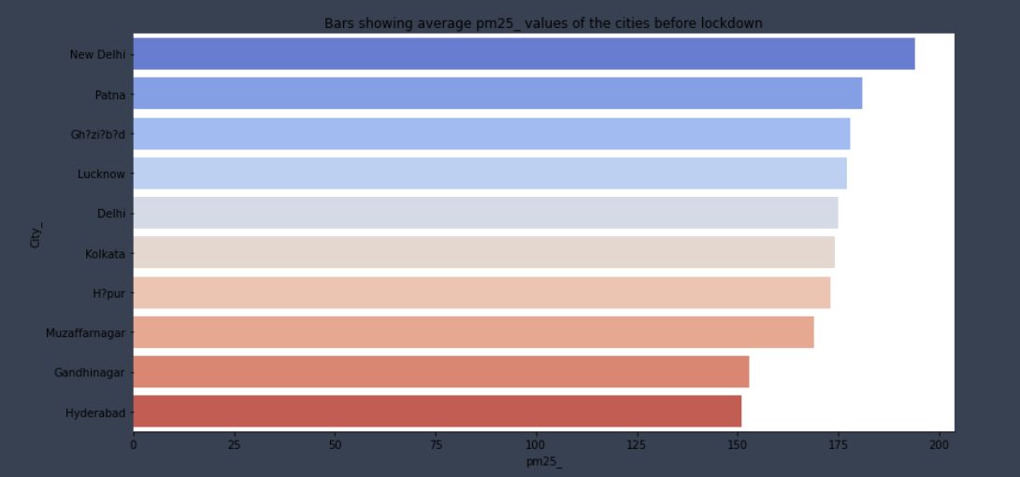

**Conclusion :**

***(These insights are before lockdown 2018-2019)***

*“As these were the cases around the Cities before lockdown period , many cities already were in bad condition ! The north-west states were Bad .Many measures were taken after the lockdown to decrease the pollution and YES, maybe we have succeded to decrease the count of pollutant , it will drastically increase after july 2020 !*

*There is* ***0.76 co-relation between So2 and No2*** *, and hence* ***Ghaziabad in No2 and Pm2.5*** *and* ***Gandhinagar in So2 and No2*** *though being* ***Sir.Narendra Modi’s*** *Hometown , pollution never decreased !*

*And* ***Delhi (The capital of India) stood out in Pm2.5 with humongous 180+ ppbv , which is worse !***

*They have to take Strict actions !*

***>> and now look at the after lockdown period (2020-recent)***

***7 . Visualization on the pollution effect POST lockdown (2020 -recent )***

*>>Total Count of Cities and Data*

*>> effect of So2 in Indian Cities*

*>> effect of No2 in Indian Cities*

*>> effect of Pm25 in Indian Cities*

*>>effect on Respiration in Indian Cities*

***Info : Good range for So2 – 10 – 35***

***Good range for No2 – 10 - 25***

*1 .* **Total Data From Cities in India** *:*

*We can observe below that we had a total of 140+ Air Quality Index data scraped from different cities across India !*

*Total Distinct Count -- 23 Cities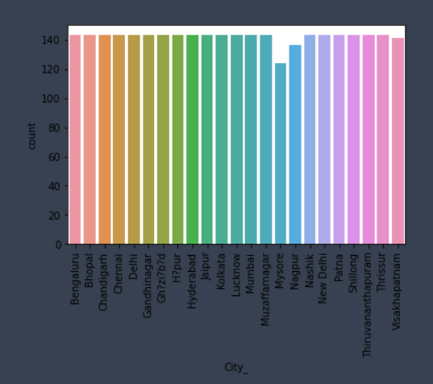Every City except Mysore has equal num of data which is helpful in bringing good insights !*

*2 .* **Effect of So2 around the Cities** *:*

*As we can see below* ***“Muzzafarnagar”(UP)*** *is ahead in avg So2 count* ***(7)******ppbv*** *after the Covid-19 lockdown followed by* ***“Shillong”(Meghalaya) (6.2)******ppbv*** *and the metro city* ***“Delhi” with 6 and “Ghaziabad”(UP) with 5.7***

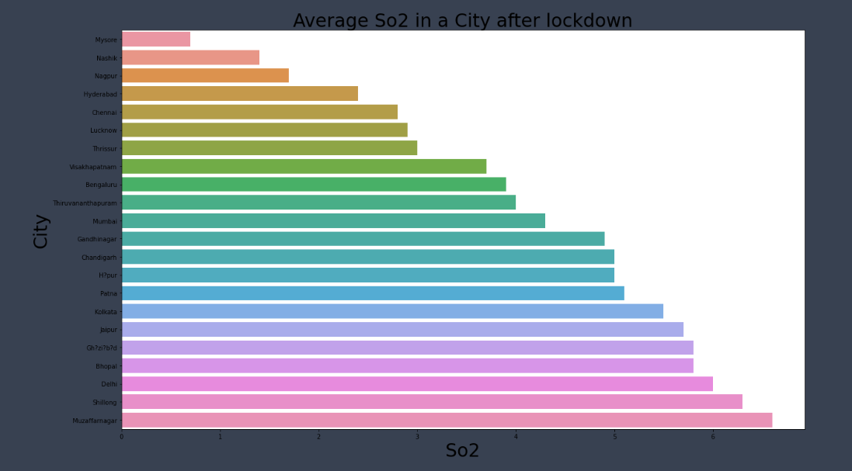

*3 .* **Effect of No2 around the Cities** *:*

*As we can see below* ***“Ghaziabad”(UP)*** *is ahead in avg No2 count* ***(19)******ppbv*** *after the Covid-19 lockdown followed by* ***“Delhi” (15)******ppbv*** *and* ***“Kolkata” with 14 .***

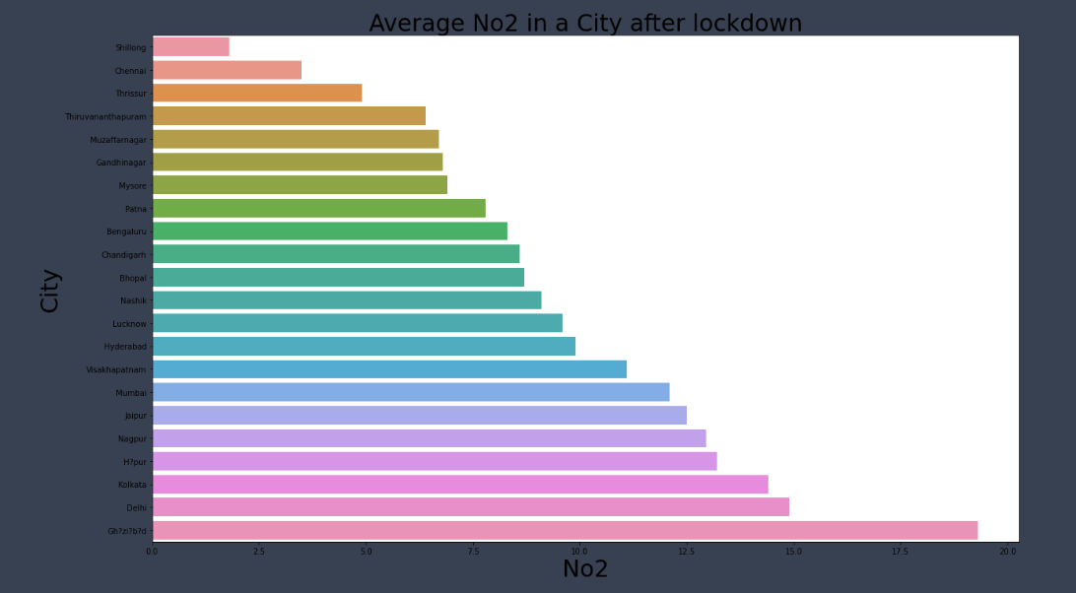

*4 .* **Effect of Pm2.5 around the Cities** *:*

*As we can see below* ***“Ghaziabad”(UP)*** *is ahead in avg Pm2.5 with count* ***(160)******ppbv*** *after the Covid-19 lockdown followed by* ***“Muzzafarnagar” (150)******ppbv*** *,****”Lucknow” (145)*** *and “****Delhi” at (140).***

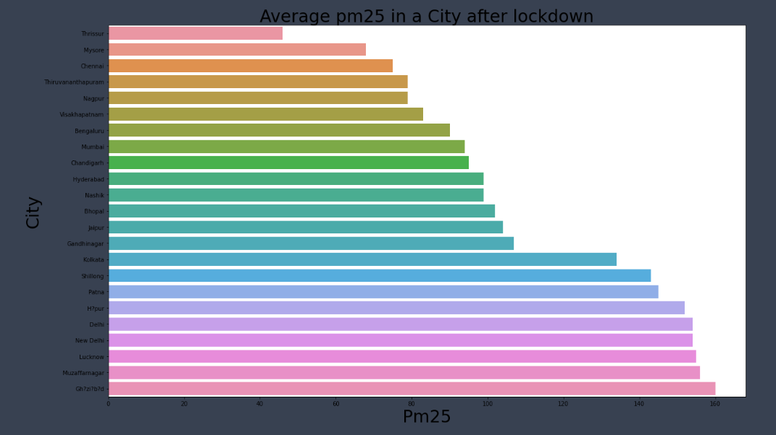

**5 . Respiratory Affected Cities (Based on Pm2.5) :**

*Since , this respiratory affected state depends on the pm2.5 ,* ***Ghaziabad*** *again tops this chart with whooping* ***160 value of pm2.5*** *, which is better than before lockdown , followed by* ***Muzzafarnagar, Lucknow and Delhi at 150 , 145 , 143 respectively !***

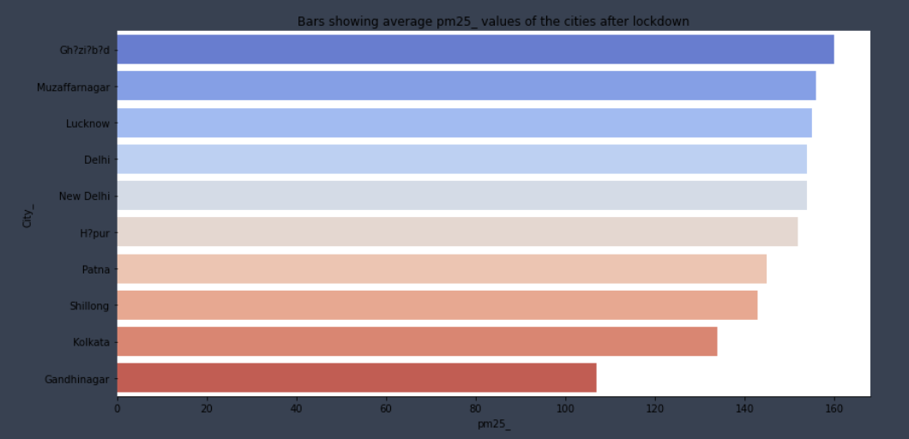

**Conclusion :**

***(These insights are after lockdown 2020- recent)***

*“As these were the cases around the Cities after lockdown period , many cities already were in bad condition before but now they have got better with 10-12 % ! The north-west states were Bad (Ghaziabad , Delhi ,Gandhinagar and Patna ) .Many measures were taken after the lockdown to decrease the pollution and YES, maybe we have succeded to decrease the count of pollutant , it will drastically increase after july 2020”*

***Comparison :***

***SO2 :***

***Before :******Gandhinagar was at 27 and Bihar at 17***

***After : Gandhinagar is reduced to 4.3 and Bihar at 5 , which is tremendous according to me !***

***No2 :***

***Before : Kolkata 31 , Gandhinagar at 30 and Delhi at 22 ppbv***

***After : Kolkata at 14 , Gandhinagar at 7 , Delhi at 15 ppbv***

***“****Gandhinagar has brought some good changes in the value with is commendabale”*

***PM2.5:***

***Before : New Delhi at 180 , Patna at 173 and Ghaziabad at 170 ppbv***

***After : New Delhi at 140 , Patna at 143 and Ghaziabad at 160 ppbv***

*“New Delhi public has made some good effort in dropping the value from 180 tp 140 , all because of the co-operation after lockdown !”*

***8 . Measures to be Taken !***

*If we look closely into the graph , majority of the location are north western area , where the literacy rate <60 % , according to that if the public are made aware about the pollution caused form their vehicle and from industries , they can take measure like :*

* **Reduce** the number of trips you take in your car.
* **Reduce** or eliminate fireplace and wood stove use.
* Avoid burning leaves, trash, and other materials.
* Avoid using gas-powered lawn and garden equipment.
* Take the Vehicle Emission test every 6 months

***9 . My Experience !***

***I , MANISH SHARMA had come a long way from searching the required datasets to handling the multilevel indexing to handling the NaN values.***

***It was overall a complete experience on my Data Analyst and Visualization part and also got to know more about pollutants and their type !***

***This Internship helped me to gain confidence and knowledge about how an Intern look like , as this was my first Project Based Internship !***

***I am Thankful to “The Shaadi Times” for selecting me out of ocean of Applicants for the position of “Data Analyst “ and believing me and helping me at every moment ☺***

***Looking forward to work with you again , till then ,***

***Thank you ☺***

***---------------***************----------------***